Name:_____________________________

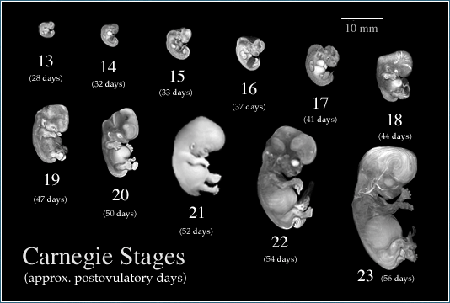
Human Fetal Growth

The complete development of a human fetus takes approximately 38 weeks from conception to birth. Increases in size and mass are two of the many changes that the fetus undergoes- both of which are used to determine the approximate age. Other developments, such as the formation of various organs, tissues, bones and body systems, also play a crucial role in determining fetal health and overall growth.
From www.chanceandchoice.com/ChanceandChoice/chapter4.html

From http://embryo.soad.umich.edu/carnStages/carnStages.html
RESOURCES

From homepage.mac.com/bogronlund/Bettina_L_inner-worlds.htm

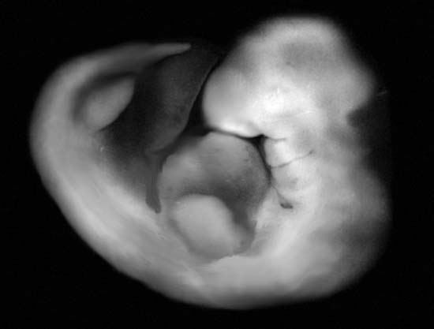
http://www.babycenter.com/fetal-development-week-by-week

http://www.webmd.com/baby/ss/slideshow-fetal-development
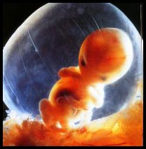

OBJECTIVES
8 Weeks
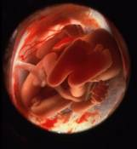
During this exercise, we will be tracking the many changes and transformations of human development from embryo to fetus to full term infant. Specifically, each student will:

- Chart the growth of the human embryo and fetus from weeks 8 through 40 using mass and length values, noting periods of greatest change. For this Exercise, we will use Microsoft Excel to create our charts.
- Note developmental milestones for each month (1 through 9) by creating a table of important physiological formations
- Review and comment on environmental & dietary hazards for the developing fetus.

HYPOTHESES: (Complete prior to going online.)

- What period of development (week or month) would show the most change in growth? What data do you think would support this?

- When do you think an embryo’s heart begins beating?

- When is it more important to avoid environmental & dietary hazards – early in pregnancy or later? Why?

PART ONE: Height and Mass Chart
Using Microsoft Excel, create a data table to record the Fetal Weight (grams) and Fetal Length (cm) found on the following website: http://www.babycenter.com/average-fetal-length-weight-chart. Record information from Weeks 8-40.

Using the chart you made, create a graph that illustrates both of these columns on one set of axes. Include proper labels and units. Print your chart and graph.

Questions:

- From your chart, do you see any times in which the embryo or fetus growth rate changed? At what weeks?

- Which weeks was the growth was the greatest or fastest?

- Why do you think that is?

PART TWO: Monthly Developments
Using the websites provided in the Resources Section, complete the table below by identifying major changes or transformations in the embryo/fetus during development.

Monthly Development Table

Development Month | Developmental Milestones or Important Changes
1
2
3
4
5
6
7
8
9

Questions:
- Each month has a different milestone for the growing embryo or fetus. Using facts from your resources explain which month or months seem most crucial for the baby’s growth? Why?

- You may have heard of the terms 1st, 2nd and 3rd Trimester as related to pregnancy. From the websites provided, identify which months and major developments that belong to which Trimester? Do this by labeling the chart on the previous page.

PART THREE: Environmental & Dietary Risks
Read the following excerpt and highlight (or underline) all environmental and dietary hazards that can affect the development of the embryo/fetus:

Timing is decisive where toxins are concerned. Air pollutants like carbon monoxide and ozone, for example, have been linked to heart defects when exposure coincided with the second month of pregnancy, the window of time during which the heart forms. Similarly, the nervous system is particularly vulnerable to damage while neurons are migrating from the part of the brain where they are made to the area where they will ultimately reside. "A tiny, tiny exposure at a key moment when a certain process is beginning to unfold can have an effect that is not only quantitatively larger but qualitatively different than it would be on an adult whose body has finished forming," observes Sandra Steingraber, an ecologist at Cornell University.

Among the substances Steingraber is most worried about are environmentally persistent neurotoxins like mercury and lead (which directly interfere with the migration of neurons formed during the first trimester) and PCBS (which, some evidence suggests, block the activity of thyroid hormone). "Thyroid hormone plays a noble role in the fetus," says Steingraber. "It actually goes into the fetal brain and serves as kind of a conductor of the orchestra."

PCBs are no longer manufactured in the U.S., but other chemicals potentially harmful to developing embryos and fetuses are. Theo Colborn, director of the World Wildlife Funds contaminants program, says at least 150 chemicals pose possible risks for fetal development, and some of them can interfere with the naturally occurring sex hormones critical to the development of a fetus. Antiandrogens, for example, are widely found in fungicides and plastics. One in particular-DDE, a breakdown product of DDT-- has been shown to cause a birth defect in which the urethra fails to extend to the end of the penis. In humans, however, notes Dr. Allen Wilcox, editor of the journal Epidemiology, the link between hormone-like chemicals and birth defects remains elusive.

The list of potential threats to embryonic life is long. It includes not only what the mother eats, drinks or inhales, but also the hormones that soar through her body. Pregnant rats with high blood glucose levels (chemically induced by wiping out their insulin) give birth to female offspring that are unusually susceptible to developing gestational diabetes. These daughter rats are able to produce enough insulin to keep their blood glucose in check, but only until they become pregnant. At that point, their glucose level soars, because their pancreases were damaged by prenatal exposure to their mother's sugar-spiked blood. The next generation of daughters is, in turn, more susceptible to gestational diabetes, and the transgenerational chain goes on.

Excerpt from TIME Magazine: “Inside the Womb”. Authors: J Madeleine Nash & David Bjerklie. New York: Nov 11, 2002.Vol.160, Iss. 20; pg. 69

Questions:

- Identify five hazards to the developing fetus that can occur in the workplace or surrounding environment:
- –

- –

- –

- –

- –

CONCLUSION/ REFLECTIONS

- Examine your hypotheses from the first page. Analyze your previous thoughts and explain how/why you were correct or incorrect for each hypothesis.
- Also, looking back on the images from page one and your work in parts 1 & 2, when (in your opinion) does the embryo begin to look “human” and achieve basic functions? Explain why.
- Finally, explain how the actions of a mother can negatively influence fetal development. Cite specific examples from the reading or a website.

